Winter 2026
Komalpreet Kaur Gill
Roy Bryan David Franck
Melika Kazemi

SMARTSTYLE

Software Requirements Specification
The Devil wears Prada | Group 04

Executive Summary
SmartStyle is an AI-assisted mobile application designed to support users in selecting appropriate outfits for different social and professional contexts. The system combines contextual inputs and rule-based logic with AI capabilities to generate outfit recommendations, reducing decision fatigue and improving user confidence.

Background
Many individuals struggle with choosing outfits that align with social expectations and personal style. Existing solutions focus primarily on shopping rather than decision support, leaving a gap for context-aware outfit recommendation systems.

Description
SmartStyle is a cross-platform mobile application developed using Flutter. It allows users to input contextual data, upload clothing images, and receive AI-assisted outfit recommendations. The system integrates Firebase for authentication, SQLite for local storage, and Gemini SDK for AI processing.

Company Value Add
The system demonstrates the ability to design and implement an AI-assisted decision-support application within defined constraints. It highlights scalable architecture, modular design, and integration with modern cloud and AI services.

End-User Value Add
Users benefit from reduced stress, faster decision-making, and increased confidence when selecting outfits. The application provides personalized, context-aware recommendations in an intuitive interface.

Scope
The project focuses on delivering a functional MVP capable of generating AI-assisted outfit recommendations using contextual inputs and stored clothing data.

What is Included
  - Mobile application (Flutter)
  - User authentication (Firebase)
  - Local storage (SQLite)
  - AI-assisted recommendations (Gemini SDK)
  - Context input (occasion, weather, formality)
  - Favorites management

What is Not Included
  - Advanced AI personalization
  - E-commerce integrations
  - Full offline capabilities
  - Multilingual support
  - AR/VR features

Justification
The project is justified by the need to address outfit decision fatigue using accessible and practical technology within academic constraints. It balances innovation and feasibility by combining AI with rule-based logic.

Table of Contents
Executive Summary 1
Background 1
Description 1
Company Value Add 1
End-User Value Add 1
Scope 1
What is Included 1
What is Not Included 2
Justification 2
Section 1 8
1.1 Document Authors 8
1.2 Document Revision History 8
1.3 Software Requirements Specification (SRS) Purpose 9
1.4 Software Requirements Specification (SRS) Audience 9
1.5 Group Agreement 9
Team Functions/Roles 10
Team Challenges 10
Team Commitment 10
Section 2 0
2.1 Project Proposal 0
2.1.1 Project Background 0
2.1.2 Problem Statement 0
2.1.3 Product Vision 0
2.2 Stakeholders & Personas 0
2.2.1 Stakeholder Overview & Needs 0
2.2.2 User Personas 1
Persona 1 1
Persona 2 2
Persona 3 2
2.3 Project Scope 2
2.3.1 Scope Statement 2
2.3.2 In-Scope 2
2.3.3 Out-of-Scope 3
2.3.4 High-Level Deliverables 4
2.3.5 Scope Assumptions 4
2.3.6 Scope Constraints 5
2.4 System Risks 5
2.4.1 Risk Register 5
2.5 Operating Environment 7
2.5.1 System Context 7
2.5.2 Hardware Environment 7
2.5.3 Software Environment 8
2.5.4 Constraints & Assumptions 8
CONSTRAINTS 8
ASSUMPTIONS 9
2.6 Functional Requirements (FR) 10
2.6.1 User Management Module 10
2.6.2 Image Capture & Input Validation Module 11
2.6.3 AI Analysis & Recommendation Module 13
2.6.4 Local Storage Module 15
2.6.5 Outfit Management Module 16
2.7 Nonfunctional Requirements (NFR) 18
2.7.1 Usability & Accessibility Requirements 18
2.7.2 Performance Requirements 19
2.7.3 Reliability & Availability 19
2.7.4 Security & Privacy 20
2.7.5 Maintainability & Scalability 20
2.8 UI/UX Interface Mock-ups 22
2.8.1 Authentication Module 22
2.8.1.1 Login Screen 22
2.8.1.2 Registration Screen 22
2.8.2 Initialization & Home Module 23
2.8.2.1 Splash Screen 23
2.8.2.2 Home Dashboard Screen 23
2.8.3 User Profile & Preferences Module 24
2.8.3.1 User Profile Screen 24
2.8.3.2 Preferences Screen 24
2.8.4 My Clothes Management Module 25
2.8.4.1 Clothes Categorization Screen 25
2.8.4.2 Clothes Details Screen 25
2.8.4.3 Upload New Clothing Screen 26
2.8.5 Outfit Recommendation Module 27
2.8.5.1 Outfit Request Form Screen 27
2.8.5.2 Outfit Results Screen 27
2.8.6 Favorites Management Module 28
2.8.6.1 Favorites List Screen 28
2.8.6.2 Favorite Details Screen 28
Section 3 29
3.1 Data Flow Diagrams 29
3.2 User Stories and related Use Case Scenarios 33
3.2.1 UC01 – Add New User 33
3.2.2 UC02 – Get Existing User 33
3.2.3 UC03 – Add a New Clothing item 34
3.2.4 UC04 – Get New Outfit Recommendations 35
3.2.5 UC05 – Delete a Favorite Outfit Recommendation 36
3.2.6 UC06 – Edit User Preferences 37
3.2.7 UC07 – Delete a Clothing Item 37
3.2.8 UC08 – Log Out 38
3.2.9 UC09 – Edit User Profile 39
3.2.10 UC10 – View User Profile 39
3.2.11 UC11 – View Clothing Items 40
3.2.12 UC12 – View Clothing Item Details 41
3.2.13 UC13 – View Favorite Outfit Recommendations 41
3.2.14 UC14 – View Favorite Outfit Recommendation Details 42
3.3 Activity Diagrams 43
3.3.1 AD01 – Add New User 43
3.3.2 AD02 – Get Existing User 44
3.3.3 AD03 – Add a New Clothing item 45
3.3.4 AD04 – Get New Outfit Recommendations 46
3.3.5 AD05 – Delete a Favorite Outfit Recommendation 47
3.3.6 AD06 – Edit User Preferences 48
3.3.7 AD07 – Delete a Clothing Item 49
3.3.8 AD08 – Log Out 49
3.3.9 AD09 – Edit User Profile 50
3.3.10 AD10 – View User Profile 51
3.3.11 AD11 – View Clothing Items 51
3.3.12 AD12 – View Clothing Item Details 51
3.3.13 AD13 – View Favorite Outfit Recommendations 52
3.3.13 AD14 – View Favorite Outfit Recommendation Details 52
3.4 Business Rules 52
Section 4 – Domain Class 55
Section 5 – Database 56
5.1 Database Schemas 56
5.1.1 User Table 56
5.1.2 Preferences Table 56
5.1.3 Wardrobe Table 57
5.1.4 Outfit Recommendation Table 58
5.1.5 Favourites Table 58
5.2 Database Diagram 60
Section 6 – Product Backlog & Implementation Schedule 62
6.1 Product Backlog 62

Section 1

Document Authors
The document authors for the present Document are:
- Komalpreet Kaur Gill
- Roy Bryan David Franck
- Melika Kazemi

1.2 Document Revision History
WEEK | DATE | Revisions
03 | Jan 25, 2026 | - Initial Documentation creation  - Sections completed: 01, 2.1
04 | Feb 01, 2026 | - Sections completed: 2.2, 2.3, 2.4 and 2.5.
05 | Feb 08, 2026 | Sections completed:  - 2.6 Functional Requirements (FR)  - 2.7 Nonfunctional Requirements (NFR)  Sections improved:  - 1.2 Document Revision History
06 | Feb 15, 2026 | Sections completed:  - 2.8 UI/UX Interface Mock-ups
07 | Mar 01, 2026 | Sections completed:  - 3.1 Data Flow Diagrams  - 3.2 User Stories and related Use Case Scenarios  - 3.3 Activity Diagrams  - 3.4 Business Rules
08 | Mar 08, 2026 | Sections improved:  - 2.8.2.2 Home Dashboard Screen  - 2.8.3.2 Preference Profile Screen  - 2.8.5.1 Outfit Request Form Screen  - 2.8.6.1 Favorites List Screen
09 | Mar 15, 2026 | Sections completed:  - 4 Domain Class
10 | March 22, 2026 | Sections completed:  - 5 Database
11 | March 29, 2026 | Sections completed:  - 7.1 Product Backlog
12 | April 12, 2026 | Sections completed:  - Executive Summary  Sections improved:  - 3.2.8 UC08 – Log Out  - 3.2.9 UC09 – Edit User Profile  - 3.2.10 UC10 – View User Profile  - 3.2.11 UC11 – View Clothing Items  - 3.2.12 UC12 – View Clothing Item Details  - 3.2.13 UC13 – View Favorite Outfit Recommendations  - 3.2.14 UC14 – View Favorite Outfit Recommendation Details  - 3.3.8 AD08 – Log Out  - 3.3.9 AD09 – Edit User Profile  - 3.3.10 AD10 – View User Profile  - 3.3.11 AD11 – View Clothing Items  - 3.3.12 AD12 – View Clothing Item Details  - 3.3.13 AD13 – View Favorite Outfit Recommendations  - 3.3.13 AD14 – View Favorite Outfit Recommendation Details

1.3 Software Requirements Specification (SRS) Purpose
The purpose of this Software Requirements Specification (SRS) document is to define the functional and non-functional requirements for the SmartStyle application. This document serves as a reference for stakeholders, developers, and evaluators by clearly describing system behavior, user interactions, constraints, and acceptance criteria. The SRS provides a foundation for system design, development, testing, and validation to ensure that SmartStyle meets its intended objectives and academic requirements.

1.4 Software Requirements Specification (SRS) Audience
This SRS document is intended for the SmartStyle development team to guide system design and implementation. It will also be used by the Professor to evaluate project scope, clarity, and requirement completeness. Additionally, this document supports collaboration by ensuring all stakeholders share a common understanding of the system.
Overall, the SRS helps align academic expectations with technical development goals.

1.5 Group Agreement
Field | Details
Team # | 04
Team Name | The Devil Wears Prada
Project Title | Smart Style
Project Time Frames | 2 Semesters (January 2026 – August 2026)
Team Members | Komalpreet Kaur Gill  Roy Bryan David Franck  Melika Kazemi
Team Leadership | Komalpreet Kaur Gill
Team Functions/Roles | Share updates via MS Teams and Google Docs: Everyone  Create and assign weekly task and mark them as completed: Everyone  Attend meetings regularly & communicate absences: Everyone  Review document draft on Friday night: Everyone  Final document uploaded by Sunday 11:00 pm: Team Leader
Team Meetings | Every Monday from 14:00 to 14:10.  Every Thursday from 12:00 to 12:15.
Team Challenges | Any challenge, disagreement, or difference of opinion would be resolved by vote. The majority decision would prevail. If an agreement does not reach, the team leader will announce the final decision.
Team Commitment | The undersigned members agree to work together on the project until the end of the PRJ666 next Semester. They recognize that as a team and individually they are equally responsible for the quality of all deliverables.  Name Date Signature  Komalpreet Kaur Gill 21/06/2026 Kgill  Roy Bryan David Franck 21/06/2026 Roy Franck  Melika Kazemi 21/06/2026 Melika

Section 2

2.1 Project Proposal
SmartStyle is an AI-assisted outfit recommendation application designed to help users choose appropriate clothing for different social and professional contexts. The project proposes a system that reduces outfit decision fatigue by using contextual inputs and predefined fashion rules to generate suitable outfit combinations.

2.1.1 Project Background
The idea for SmartStyle emerged from the common challenge faced by students and professionals who struggle to decide what to wear for interviews, events, and everyday activities. Existing fashion applications largely focus on shopping and product discovery, offering limited support for outfit decision-making based on context such as occasion, formality, and social setting.

2.1.2 Problem Statement
Users often have trouble and stress when selecting outfits due to the need to balance personal style, social expectations, and situational appropriateness. The absence of tools that provide context-aware outfit recommendations forces users to rely on trial-and-error, leading to decision fatigue, wasted time, and reduced confidence.

2.1.3 Product Vision
The vision of SmartStyle is to provide a user-friendly, AI-assisted decision-support system that recommends context-appropriate outfit combinations based on user preferences and situational inputs. The long-term goal is to allow users share their favourites outfits combination made by SmartStyle to their friends.

2.2 Stakeholders & Personas

2.2.1 Stakeholder Overview & Needs
This section identifies the key stakeholders involved in or affected by the SmartStyle system and summarizes their goals, needs, concerns, and level of influence on the project. Stakeholders are defined by role rather than individual names.
Stakeholder Role / Organization | Primary Interest / Goals | Key Needs | Key Concerns | Influence
End Users (Students & Professionals) | Receive reliable, context-appropriate outfit recommendations | Easy-to-use interface, relevant suggestions, customization options | Inaccurate recommendations, limited personalization | Medium
Project Sponsor / Course Instructor | Ensure project meets academic objectives and learning outcomes | Clear scope, realistic implementation, proper documentation | Over-scoping, unclear AI claims, missed deadlines | High
Development Team | Build a functional, maintainable system within timeline | Well-defined requirements, clear roles, manageable scope | Scope creep, integration issues | Medium
Future Platform Partners (Retailers / Fashion Services) | Potential integration or exposure of outfit suggestions | Scalable architecture, integration readiness | Misalignment with platform goals, data usage concerns | Low
Stakeholder concerns related to scope, recommendation accuracy, and system complexity directly inform identified system risks, including overpromising AI functionality, usability challenges, and integration limitations.

2.2.2 User Personas

Persona 1
Persona Name: Alex
User Type: University Student
Background: Alex is a full-time student who attends classes, interviews, and social events and often feels unsure about appropriate outfit choices.
Goals: Quickly select suitable outfits for different occasions without stress or overthinking.
Pain Points: Decision fatigue, lack of confidence in outfit choices, limited time in the morning.
Technology Comfort Level: High
Primary Usage Scenarios: Preparing for presentations, interviews, and social gatherings.

Persona 2
Persona Name: Sarah
User Type: Young Professional
Background: Sarah works in a professional environment and frequently attends meetings and formal events.
Goals: Maintain a professional appearance while expressing personal style.
Pain Points: Uncertainty about dress codes, limited outfit variety, fear of appearing underdressed or overdressed.
Technology Comfort Level: Medium to High
Primary Usage Scenarios: Workdays, client meetings, professional events.

Persona 3
Persona Name: Jordan
User Type: Casual User
Background: Jordan uses SmartStyle occasionally for social outings and special events.
Goals: Receive quick outfit ideas for casual and semi-formal occasions.
Pain Points: Matching colors and styles, lack of inspiration.
Technology Comfort Level: Medium
Primary Usage Scenarios: Social outings, parties, informal events.

2.3 Project Scope
This section defines the boundaries of the project by clearly identifying what is included and excluded from scope.

2.3.1 Scope Statement
This project will design and implement a system that provides AI-assisted, context-aware outfit recommendations to support users in selecting appropriate clothing for different social and professional situations. The system is intended to support individuals seeking to reduce outfit decision fatigue and address challenges related to time consumption, stress, and uncertainty when choosing what to wear. The scope of this project is intentionally limited to the features and deliverables defined below.

2.3.2 In-Scope
The following items are included within the scope of this project.
In-Scope Item ID | Description
IS-01 | Mobile application developed using Flutter for Android and iOS devices.
IS-02 | User account creation and authentication using Firebase Firestore.
IS-03 | Local storage of user data and preferences using SQLite.
IS-04 | AI-assisted outfit recommendation using Gemini SDK and rule-based decision logic.
IS-05 | Collection of contextual inputs (occasion type, social setting, weather, formality).
IS-06 | Mobile-responsive UI.
IS-07 | App distribution through Google Play Store and Apple App Store.
IS-08 | Storage favourite outfits recommendation locally on the device memory using SQLite.

2.3.3 Out-of-Scope
The following items are explicitly excluded from the scope of this project.
Out-of-Scope Item ID | Description
OS-01 | Advanced AI personalization or predictive styling based on large-scale user data.
OS-02 | Integration with third-party e-commerce or fashion retailers.
OS-03 | Full offline functionality beyond basic local storage.
OS-04 | Multilingual support beyond English (future iterations possible).
OS-05 | Wearable device integration or AR/VR outfit visualization.

2.3.4 High-Level Deliverables
The following high-level deliverables will be produced as part of this project.
Deliverable ID | Deliverable Description
D-01 | Mobile application for Android and iOS developed in Flutter, intended for local testing only and not yet distributed via app stores.
D-02 | Backend setup: Firebase Firestore for authentication and cloud data.
D-03 | Local data storage module using SQLite.
D-04 | AI-assisted outfit recommendation engine with Gemini SDK integration.
D-05 | Mobile user interface with basic accessibility and responsive design.

2.3.5 Scope Assumptions
Assumptions that directly impact project scope. (Do not repeat global assumptions already listed earlier.)
Assumption ID | Assumption Description
SA-01 | Users will have smartphones with Android or iOS and internet access.
SA-02 | Users are willing to provide basic contextual information (occasion, weather, social setting) to receive outfit recommendations.
SA-03 | AI API (Gemini SDK) is available and responsive during testing and deployment.
SA-04 | Firebase Firestore provides sufficient free-tier resources for development and early deployment.
SA-05 | Users are willing to provide clear photos of their clothing items and grant the app access to use these images as context for the AI-based outfit recommendation feature.

2.3.6 Scope Constraints
Constraints that directly limit or shape project scope. (Do not repeat technical or organizational constraints already captured.)
Constraint ID | Constraint Description
SC-01 | The MVP is limited to rule-based and basic AI-assisted outfit recommendations; advanced ML personalization is excluded.
SC-02 | Data privacy and encryption are constrained to Firebase security and local device storage; no additional enterprise-grade security infrastructure is planned.
SC-03 | The AI recommendation feature relies on the availability and responsiveness of the Gemini SDK; any downtime or API changes may affect the system.

2.4 System Risks

2.4.1 Risk Register
This section identifies risks that could negatively impact system development, deployment, or operation.
Risk ID | Risk Description | Category | Likelihood | Impact | Mitigation / Control | Owner (Role)
R-01 | The AI API (Gemini SDK) may experience downtime or breaking changes, causing outfit recommendations to fail. | Technical | Medium | High | Implement fallback rule-based logic and monitor API availability during development and testing. | Backend Developer
R-02 | Inconsistent or low-quality user-uploaded photos may reduce the accuracy of outfit recommendations. | Technical | Medium | Medium | Use AI-based image analysis to detect low-quality images or photos that do not clearly show a single clothing item, and return clear feedback requesting the user to upload a suitable image. | Backend Developer
R-03 | User data or photos could be exposed due to misconfigured cloud security rules. | Security | Low | High | Apply Firebase security rules, enforce encryption in transit, and perform basic security testing. | Backend Developer
R-04 | Scope creep may occur if additional features are requested beyond the defined MVP, impacting timeline and quality. | Schedule | Medium | Medium | Maintain a prioritized backlog and require scope review and approval for any new features. | Product Owner
R-05 | Limited development time may prevent full implementation of all planned features. | Schedule | Medium | High | Focus on MVP features first and de-scope non-critical functionality if necessary. | Project Manager
R-06 | Users may be unwilling to upload photos due to privacy concerns, limiting AI feature usage. | Business | Low | Medium | Clearly communicate privacy policies and allow basic recommendations without photo uploads. | Frontend Developer
R-07 | App performance may degrade on lower-end mobile devices. | Operatioal | Low | Medium | Optimize image handling and test the app on multiple device configurations. | Frontend Developer

2.5 Operating Environment

2.5.1 System Context
The system is a cross-platform mobile application developed using Flutter, designed to run on Android and iOS operating systems and accessed by users through their smartphones. The application will be publicly available for download via the Google Play Store and the Apple App Store, making it accessible to external users.
User authentication and account management will be handled using Firebase Firestore, providing cloud-based storage and secure user data management. Selected application data will be stored locally on the device using SQLite to support faster access and limited offline functionality.
Communication with AI services will be performed through the Gemini SDK, which enables interaction with an external AI API for outfit recommendation support.

2.5.2 Hardware Environment
Component | Description
User Device | Smartphone or tablet capable of running Android or iOS, with internet connectivity and camera access for photo uploads.
Server Infrastructure | Cloud-hosted servers provided by third-party cloud platforms (e.g., Firebase and AI service providers).
Network | Internet connection (Wi-Fi or mobile data) required for authentication, AI processing, and data synchronization.

2.5.3 Software Environment
Component | Description
Operating System | Android and iOS operating systems.
Application Framework | Flutter cross-platform framework for mobile application development.
Authentication & User Data | Firebase Firestore for user authentication and cloud-based data storage.
Local Data Storage | SQLite for local, device-level data persistence and offline access.
AI Integration | Gemini SDK for communication with the external AI API.
AI Integration | Google Play Store and Apple App Store for application deployment and updates.

2.5.4 Constraints & Assumptions

CONSTRAINTS
Regulatory / Institutional Constraints:
SmartStyle is developed as an academic project and must comply with institutional guidelines regarding ethical data use, privacy, and academic integrity. The system will avoid collecting sensitive personal data and will not rely on third-party datasets that require paid licenses or special permissions.
Technology / Hosting Constraints:
The application will be developed using commonly available web and mobile technologies suitable for student projects. Hosting and deployment will be limited to free or low-cost cloud services, which may impose restrictions on storage, compute resources, and scalability.
Budget / Timeline Constraints:
The project is constrained by a fixed two-semester academic timeline and limited financial resources. All development must be completed using open-source tools and services, and advanced AI or machine learning infrastructure beyond the MVP scope may not be feasible.

ASSUMPTIONS
Expected User Behavior:
It is assumed that users will provide accurate and sufficient contextual input, such as occasion type and preferences, to enable meaningful outfit recommendations. Users are also expected to understand that recommendations are advisory rather than definitive.
Infrastructure Availability:
It is assumed that users will have access to a stable internet connection and a modern web or mobile device capable of running the SmartStyle application.
Data Access / System Integrations:
The system assumes that outfit data will primarily be user-provided through uploaded images or manual input. No mandatory external data sources or third-party system integrations are required for the initial MVP.

2.6 Functional Requirements (FR)

2.6.1 User Management Module
Defines how users create accounts, authenticate securely, maintain active sessions, and protect access to user-specific data within the application.
Requirement ID | Requirement Statement | Acceptance Criteria | Priority | Rationale
FR-UM-01 | The system shall allow users to create an account using an email and password. | A user can successfully register and is stored in Firebase Firestore with a unique identifier. | Must | User identification is required to personalize outfit recommendations.
FR-UM-02 | The system shall authenticate registered users using Firebase Firestore. | Valid credentials grant access to the application; invalid credentials return an error message. | Must | Secure access control is essential for user-specific data.
FR-UM-03 | The system shall maintain an authenticated user session during app usage. | Users remain logged in until they explicitly log out or the session expires. | Must | Improves usability and reduces repeated authentication.
FR-UM-04 | The system shall allow users to log out of the application. | User session is terminated and access to protected features is revoked. | Must | Required for basic security and account control.
FR-UM-05 | The system shall securely store basic user profile data. | User profile data is retrievable after login and persists across sessions. | Should | Enables future personalization without expanding scope.
FR-UM-06 | The system shall prevent unauthorized access to user-specific data. | Users cannot access data belonging to other users. | Must | Protects user privacy and aligns with security constraints.
FR-UM-07 | The system shall display meaningful authentication error messages. | Users receive clear feedback for incorrect credentials or connection issues. | Should | Improves user experience and reduces support issues.

2.6.2 Image Capture & Input Validation Module
Defines how users capture or upload individual clothing images and how the system validates image quality and suitability using AI-assisted analysis before further processing.
Requirement ID | Requirement Statement | Acceptance Criteria | Priority | Rationale
FR-IC-01 | The system shall allow users to capture photos of clothing items using the device camera. | The camera opens and successfully captures an image. | Must | Image input is required for AI-assisted recommendations.
FR-IC-02 | The system shall allow users to upload existing photos from the device gallery. | Selected images are successfully attached to the recommendation process. | Must | Provides flexibility in how users provide clothing images.
FR-IC-03 | The system shall submit uploaded images to the AI service for validation. | The AI returns a validation response indicating image suitability. | Must | Ensures image quality before recommendation processing.
FR-IC-04 | The system shall reject images that are blurry, low-quality, or contain multiple clothing items. | The user receives a clear message explaining why the image was rejected. | Should | Reduces inaccurate AI recommendations caused by poor inputs.
FR-IC-05 | The system shall display AI-generated feedback when image validation fails | Feedback includes guidance on how to improve the image. | Should | Improves user understanding and resubmission success.
FR-IC-06 | The system shall submit validated clothing images to the AI service for semantic analysis. | The AI service confirms that the image is ready for category and description generation. | Must | Prepares validated images for AI-based understanding before outfit generation.

2.6.3 AI Analysis & Recommendation Module
Defines how the system analyzes contextual inputs and validated clothing data using AI-assisted logic and rule-based constraints to generate outfit recommendations.
Requirement ID | Requirement Statement | Acceptance Criteria | Priority | Rationale
FR-AI-01 | The system shall analyze user-provided contextual inputs using AI-assisted logic. | Contextual inputs are successfully processed by the AI service. | Must | Context is required to generate relevant outfit recommendations.
FR-AI-02 | The system shall combine AI output with predefined rule-based decision logic. | Generated outfits comply with defined style, formality, and color-matching rules. | Must | Ensures consistent and explainable recommendations in the MVP.
FR-AI-03 | The system shall generate two visual outfit recommendations based on validated images and contextual inputs. | Two outfit images are generated and displayed to the user per request. | Must | Provides choice while limiting cognitive overload.
FR-AI-04 | The system shall allow users to accept one of the generated outfit recommendations. | The selected outfit is marked as accepted and becomes available for saving or reuse. | Must | Enables user-driven decision confirmation.
FR-AI-05 | The system shall allow users to request a new set of outfit recommendations. | Two new outfit images are generated upon user request. | Must | Supports iterative exploration without restarting the flow.
FR-AI-06 | The system shall handle AI service errors gracefully. | The user receives a clear and friendly error message without application failure. | Must | Ensures reliability when external AI services fail.
FR-AI-07 | The system shall analyze validated clothing images to determine a clothing category. | A category (e.g., top, bottom, footwear, outerwear) is returned by the AI service. | Must | Categorization is required to assemble compatible outfits.
FR-AI-08 | The system shall generate a textual description for each validated clothing image. | A concise and structured description is returned by the AI service. | Must | Text descriptions replace images as the primary input for outfit generation.
FR-AI-09 | The system shall use AI-generated textual descriptions as the primary input for outfit recommendation generation. | Outfit recommendations are generated without reprocessing original images. | Must | Optimizes resource usage and reduces repeated image processing.

2.6.4 Local Storage Module
Defines how user preferences, AI-generated clothing descriptions, and outfit-related data are stored, isolated per user, and retrieved locally using SQLite.
Requirement ID | Requirement Statement | Acceptance Criteria | Priority | Rationale
FR-LS-01 | The system shall store user preferences locally using SQLite. | Preferences persist after app restart. | Must | Enables faster access and basic offline support.
FR-LS-02 | The system shall store favorite outfit recommendations locally. | Saved outfits can be viewed later by the user. | Must | Supports user engagement and reuse of recommendations.
FR-LS-03 | The system shall allow users to delete locally stored data. | Deleted items are removed from the local database. | Should | Gives users control over local data storage.
FR-LS-04 | The system shall retrieve locally stored data without requiring network access. | Data is accessible while offline. | Could | Enhances usability without expanding MVP scope.
FR-LS-05 | The system shall isolate local data per authenticated user. | No data leakage occurs between user sessions. | Must | Protects user privacy on shared devices.
FR-LS-06 | The system shall store AI-generated clothing categories and textual descriptions locally using SQLite. | Stored descriptions persist across app sessions. | Must | Enables reuse of AI outputs without repeated processing.
FR-LS-07 | The system shall associate each stored clothing description with a local image reference or tag. | Each description can be traced back to its corresponding image. | Must | Each description can be traced back to its corresponding image.

2.6.5 Outfit Management Module
Defines how users view, save, remove, and manage generated outfit recommendations along with associated contextual metadata.
Requirement ID | Requirement Statement | Acceptance Criteria | Priority | Rationale
FR-OM-01 | The system shall display generated outfit recommendations to the user. | Recommendations are visible in a clear and organized layout. | Must | Enables users to consume system output.
FR-OM-02 | The system shall allow users to save outfit recommendations as favorites. | Saved outfits are stored locally using SQLite. | Must | Supports repeated use of preferred outfits.
FR-OM-03 | The system shall allow users to remove saved outfit recommendations. | The selected outfit is removed from favorites. | Should | Provides basic outfit management control.
FR-OM-04 | The system shall allow users to view previously saved outfits. | Saved outfits are displayed from local storage. | Must | Improves usability and long-term value.
FR-OM-05 | The system shall associate saved outfits with contextual metadata. | Metadata such as occasion and formality is stored and retrievable. | Could | Supports future filtering and enhancements.

2.7 Nonfunctional Requirements (NFR)

2.7.1 Usability & Accessibility Requirements
Defines the constraints and quality attributes that ensure the SmartStyle application is easy to learn, efficient to use, and accessible to a wide range of users, including those with differing abilities.
Requirement ID | Requirement Statement | Acceptance Criteria | Priority | Rationale
NFR-USA-01 | The system shall provide an intuitive and easy-to-use mobile interface suitable for non-technical users. | First-time users can complete an outfit recommendation flow without assistance. | Must | Reduces learning curve and improves user adoption.
NFR-USA-02 | The system shall minimize the number of user interactions required to generate an outfit recommendation. | A recommendation can be generated within 3–5 user interactions after login. | Must | Reduces decision fatigue and improves efficiency.
NFR-USA-03 | The system shall present readable text, icons, and controls on common mobile screen sizes. | Text and controls remain legible on small and medium screen devices. | Must | Ensures usability across different devices.
NFR-USA-04 | The system shall provide clear and meaningful feedback for errors or invalid inputs. | Error messages explain the issue and suggest corrective action. | Should | Improves user understanding and reduces confusion.
NFR-USA-05 | The system shall support basic accessibility features provided by the mobile operating system. | The app functions correctly with screen readers and system font scaling enabled. | Should | Improves accessibility for users with visual or motor impairments.

2.7.2 Performance Requirements
Defines system performance expectations such as acceptable response times, screen load times, and smooth operation on typical mobile devices under normal network conditions.
Requirement ID | Requirement Statement | Acceptance Criteria | Priority | Rationale
NFR-PERF-01 | The system shall generate outfit recommendations within an acceptable response time. | Recommendations are displayed within ≤5 seconds in 95% of test runs. | Must | Ensures smooth user experience.
NFR-PERF-02 | The system shall load primary application screens within an acceptable time on mobile devices. | Core screens load within ≤2 seconds on mid-range devices. | Should | Improves perceived responsiveness.

2.7.3 Reliability & Availability
Defines requirements that ensure the system remains stable, preserves user data, and continues providing core functionality even when external services (e.g., AI APIs) are unavailable.
Requirement ID | Requirement Statement | Acceptance Criteria | Priority | Rationale
NFR-REL-01 | The system shall continue to provide basic functionality when external AI services are unavailable. | Rule-based recommendations are returned when AI API fails. | Must | Ensures continuity of core features.
NFR-REL-02 | The system shall preserve user preferences and saved outfits across app restarts. | Data remains intact after app restart or device reboot. | Must | Prevents data loss and improves trust.

2.7.4 Security & Privacy
Defines security and privacy constraints to protect user accounts, personal data, and uploaded images through secure authentication, encrypted communication, and controlled data access.
Requirement ID | Requirement Statement | Acceptance Criteria | Priority | Rationale
NFR-SEC-01 | The system shall protect user authentication and access using Firebase security mechanisms. | Unauthorized users cannot access protected features or data. | Must | Prevents unauthorized access.
NFR-SEC-02 | The system shall encrypt all data transmitted between the application and external services. | Network inspection confirms HTTPS is enforced. | Must | Protects sensitive data in transit.
NFR-SEC-03 | The system shall limit use of user photos and personal data to required processing only. | Only required fields are sent to AI services. | Must | Ensures ethical data usage and privacy.

2.7.5 Maintainability & Scalability
Defines architectural and design constraints that allow the system to be easily maintained, extended, and enhanced in future iterations without major refactoring.
Requirement ID | Requirement Statement | Acceptance Criteria | Priority | Rationale
NFR-SCAL-01 | The system shall use a modular architecture separating UI, storage, and AI logic. | Code review confirms clear separation of components. | Should | Simplifies maintenance and future enhancements.
NFR-SCAL-02 | The system shall allow new recommendation rules to be added without major refactoring. | New rules can be introduced without modifying unrelated modules. | Could | Supports future expansion beyond MVP.

2.8 UI/UX Interface Mock-ups

2.8.1 Authentication Module

2.8.1.1 Login Screen
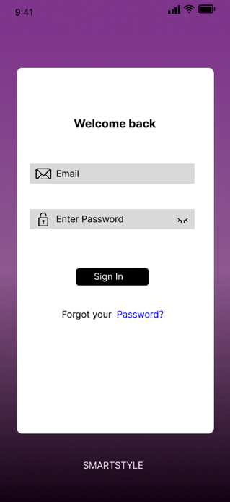

2.8.1.2 Registration Screen
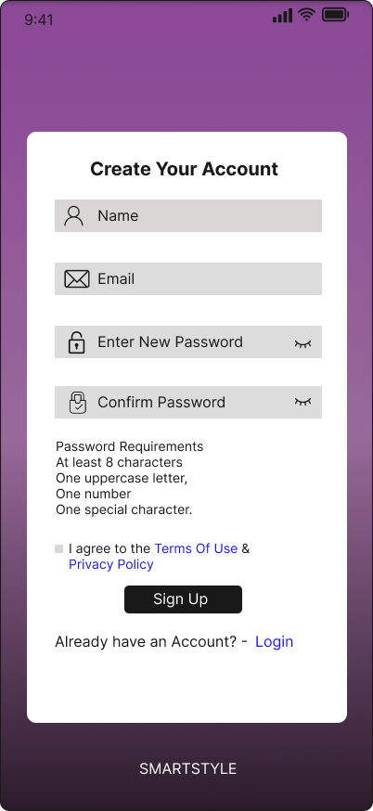

2.8.2 Initialization & Home Module

2.8.2.1 Splash Screen


2.8.2.2 Home Dashboard Screen
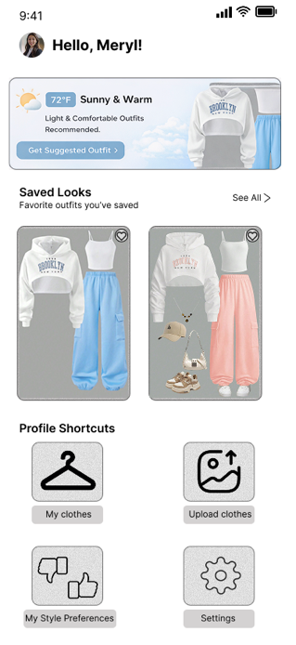

2.8.3 User Profile & Preferences Module

2.8.3.1 User Profile Screen
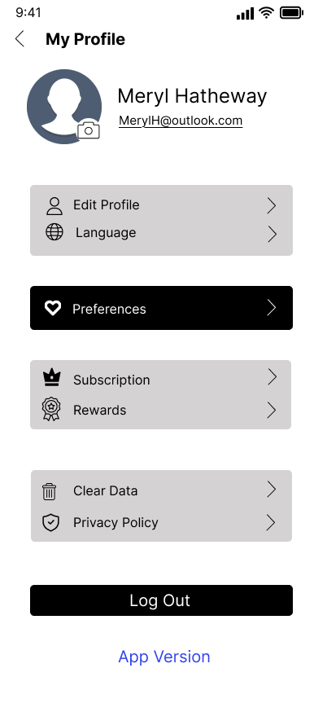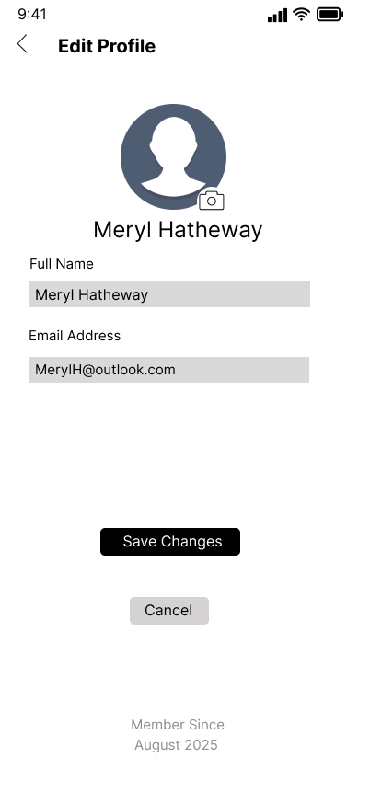

2.8.3.2 Preferences Screen
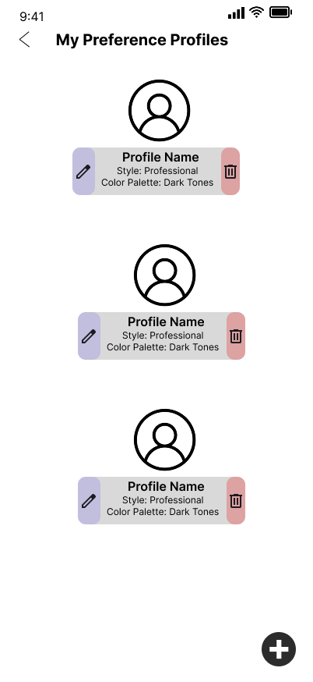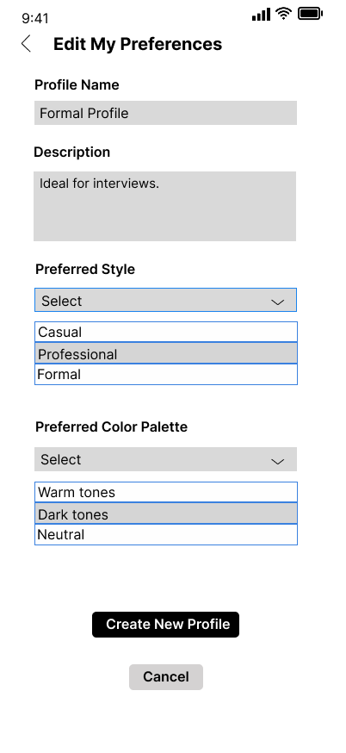

2.8.4 My Clothes Management Module

2.8.4.1 Clothes Categorization Screen
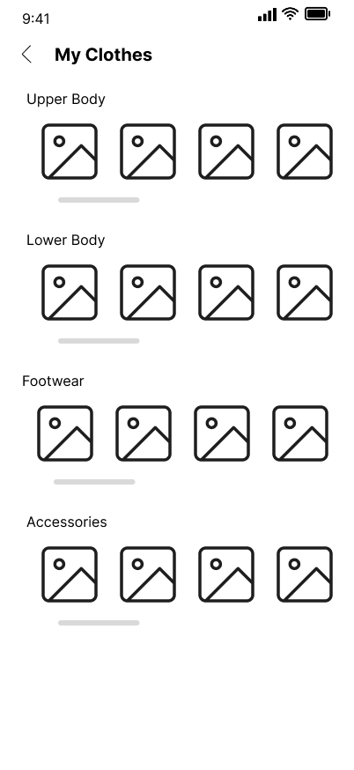

2.8.4.2 Clothes Details Screen
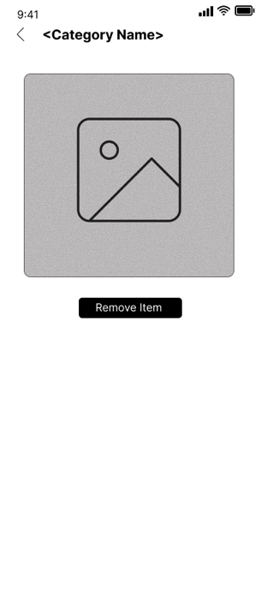

2.8.4.3 Upload New Clothing Screen
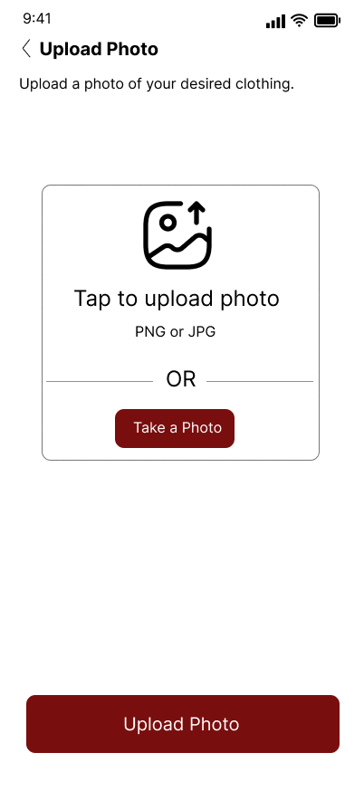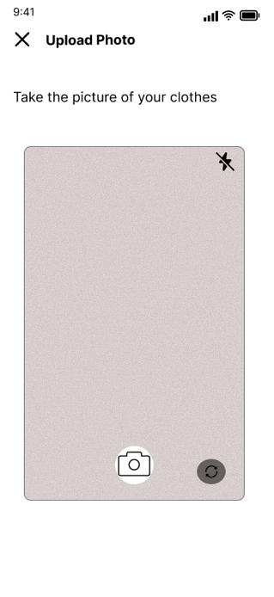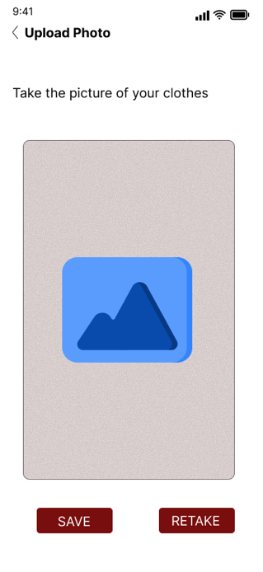
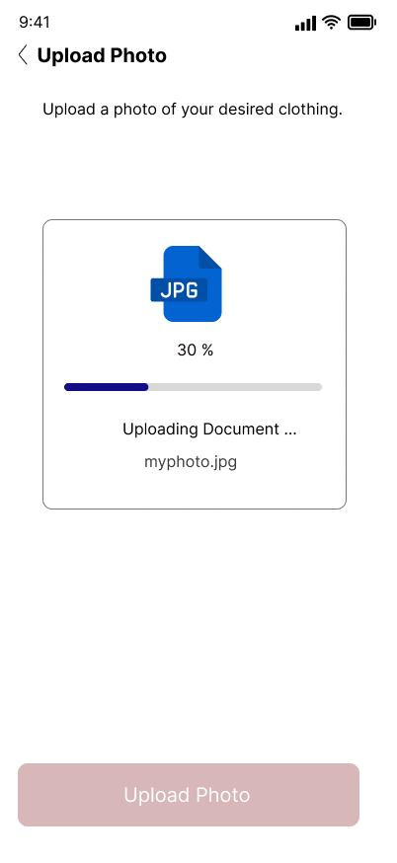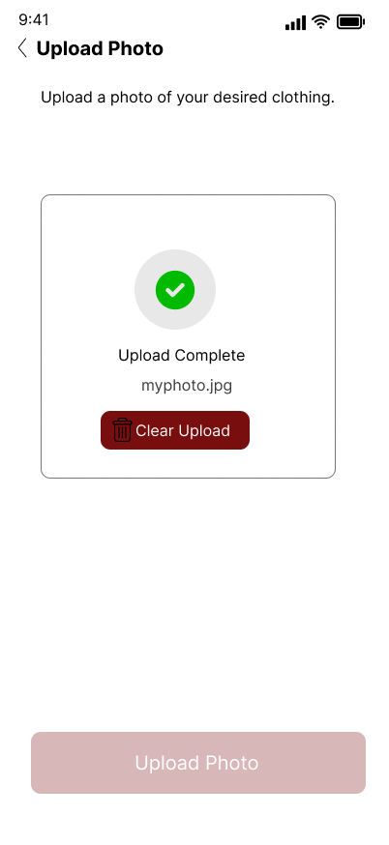

2.8.5 Outfit Recommendation Module

2.8.5.1 Outfit Request Form Screen
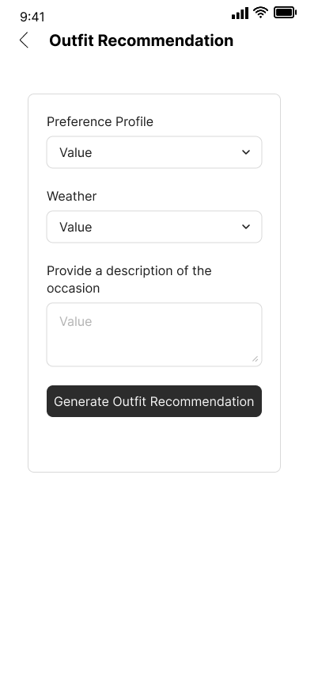

2.8.5.2 Outfit Results Screen
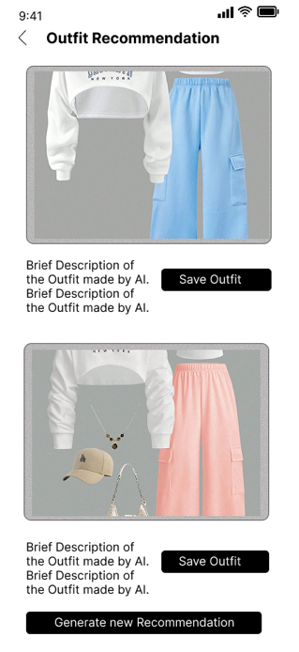

2.8.6 Favorites Management Module

2.8.6.1 Favorites List Screen
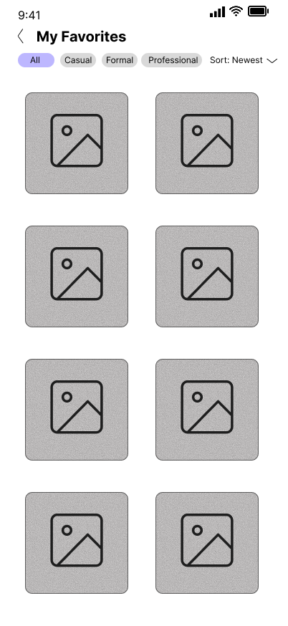

2.8.6.2 Favorite Details Screen
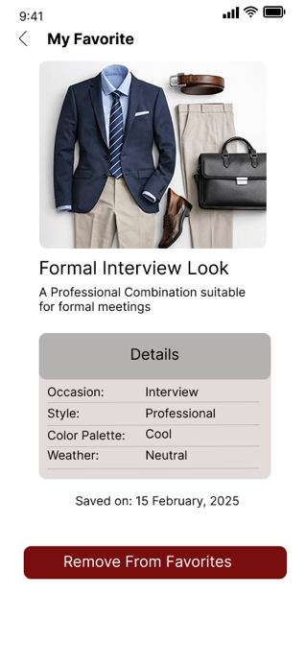

Section 3

3.1 Data Flow Diagrams
DFD #1: Main System Process Level 0
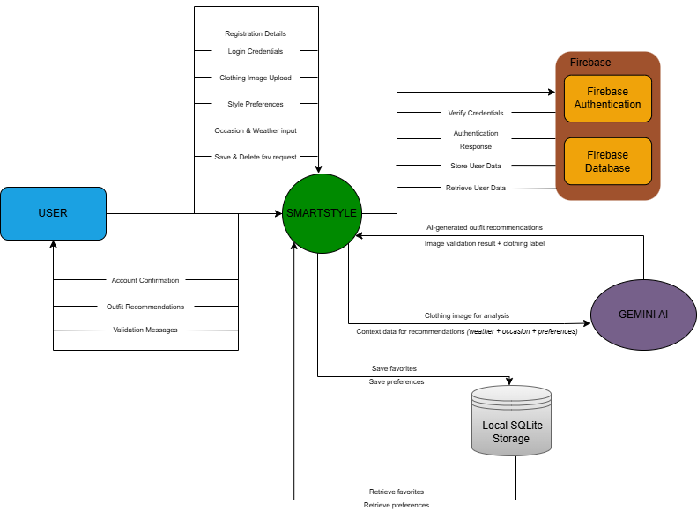

DFD #2: Authentication Level 1
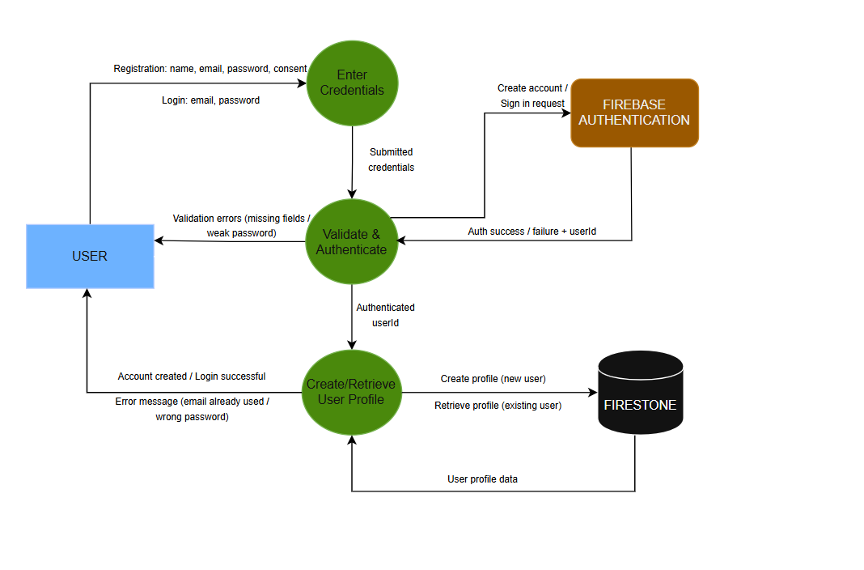
DFD #3: Upload Clothing DFD Level 01
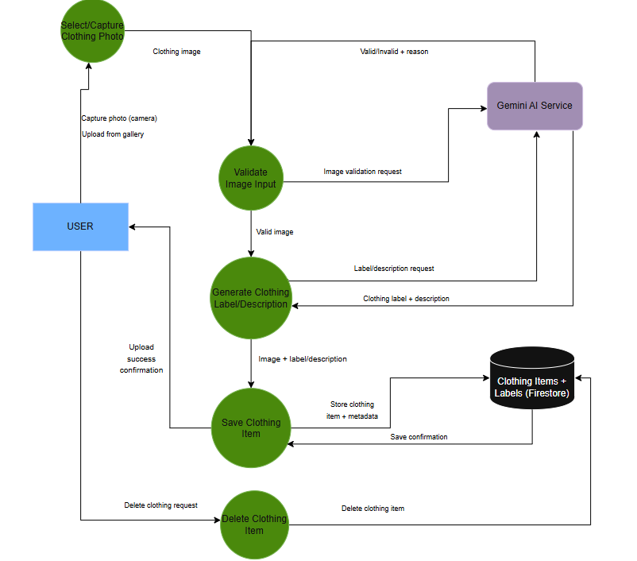
DFD #4: Outfit Recommendation Flow Level 01
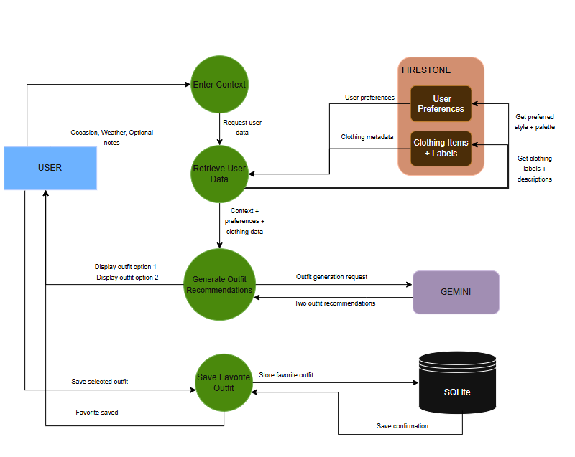

DFD #5: Local Storage & Preferences Management Level 01

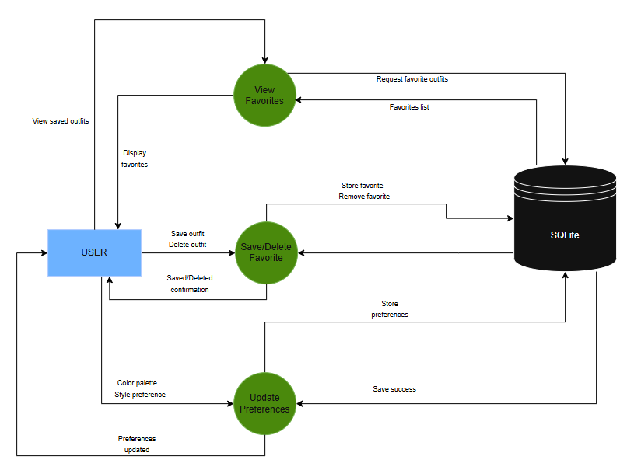

3.2 User Stories and related Use Case Scenarios

3.2.1 UC01 – Add New User
User Story:
As a user, I want to create a new account so that I can access the application.
User Case Description:
Use Case Description Name |  | Add New User
Triggering Event |  | A new User Account is required
Brief Description |  | Allows the User to create a new account
Actors |  | User
Related Use Cases
Preconditions |  | User has opened the Registration Screen
Post Conditions |  | The new Account is saved to the database and now can be accessed
Flow of activities |  | Actor | System
 |  | Request to create a new user account | Get the Terms of Use. Get the Privacy Policy. Display the Terms of Use and the Privacy Policy.  Prompts for name, email, password and to accept the Terms of Use and Privacy Policy.
 |  | Enters name, email, password and accept the Terms of Use and Privacy Policy. | Validates Data. Get the existing user accounts. Verify the email is not currently used by other account.  Prompts to Save data.
 |  | Request to save data. | Saves the new account.
Exception Conditions |  | - User chooses to cancel creating a new user account.

3.2.2 UC02 – Get Existing User
User Story:
As a user, I want to log in to my account so that I can access my profile and my saved data.
User Case Description:
Use Case Description Name |  | Get Existing User
Triggering Event |  | An existing User wants to access his data
Brief Description |  | Allows the User to log in into his account
Actors |  | User
Related Use Cases
Preconditions |  | User has opened the Login Screen
Post Conditions |  | The Account is retrieved from the database and user data can be accessed
Flow of activities |  | Actor | System
 |  | Requests to log in | Prompts for email and password.
 |  | Enters email and password. | Validates Data. Get the existing user account.
Exception Conditions |  | - User chooses to cancel the login.

3.2.3 UC03 – Add a New Clothing item
User Story:
As a user, I want to add a new clothing item so that the system can analyze it and use it for outfit recommendations.
User Case Description:
Use Case Description Name |  | Add a New Clothing Item
Triggering Event |  | An existing user wants to upload a picture of a clothing item
Brief Description |  | Allows the User to load a picture of a single clothing item to be used in the generation of Outfit Recommendation
Actors |  | User
Related Use Cases
Preconditions |  | User has opened the Upload New Clothing Screen
Post Conditions |  | The Clothing Item was validated and now can be retrieved from the database
Flow of activities |  | Actor | System
 |  | Request to add a new clothing item | Prompts the user to provide a photo of a single clothing item
 |  | Selects or captures a photo | Validate the content of the photo. Generates a description label about the clothing item.  Prompts for saving.
 |  | Request to save data. | Saves the photo and its label description.
Exception Conditions |  | - User chooses to cancel the loading.

3.2.4 UC04 – Get New Outfit Recommendations
User Story:
As a user, I want to receive outfit recommendations based on my clothes and context so that I can decide what to wear.
User Case Description:
Use Case Description Name |  | Get New Outfit Recommendations
Triggering Event |  | An existing user wants to get New Outfit Recommendations
Brief Description |  | Allows the User to get new outfit recommendations using its own clothes as a reference.
Actors |  | User
Related Use Cases
Preconditions |  | User has opened the Outfit Request Form Screen
Post Conditions |  | The system has generated two outfit recommendations to the user.
Flow of activities |  | Actor | System
 |  | Request to get New Outfit Recommendations | Prompts for the weather and a description of the occasion
 |  | Enters the weather and the description. | Validates the data.  Get the user preferences.  Get the user Clothing items label description.  Generates two outfit recommendation with the given data.  Prompts for saving.
 |  | Request to save data. | Save the Outfit Recommendation as a Favorite
Exception Conditions |  | - User chooses to cancel the outfit recommendation generation.  - User chooses to re generate the outfit recommendations.

3.2.5 UC05 – Delete a Favorite Outfit Recommendation
User Story:
As a user, I want to delete a favorite outfit recommendation so that I can save only the ones I like.
User Case Description:
Use Case Description Name |  | Delete a Favorite Outfit Recommendation
Triggering Event |  | An existing user wants to delete a Favorite Outfit Recommendation
Brief Description |  | Allows the User to delete a outfit recommendation from the favorites.
Actors |  | User
Related Use Cases
Preconditions |  | The System has successfully saved the outfit recommendation as a favorite
Post Conditions |  | The system deletes the chosen outfit recommendation from the database.
Flow of activities |  | Actor | System
 |  | Request to get all the favorites outfit recommendations | Get the user favorite outfit recommendation  List the favorites
 |  | Select a favorite outfit recommendation | Get the outfit recommendation details.  List the details.  Prompt for Deletion
 |  | Request to delete the favorite outfit recommendation | Delete the outfit recommendation from the favorites
Exception Conditions |  | - User chooses to cancel.

3.2.6 UC06 – Edit User Preferences
User Story:
As a user, I want to update my style preferences and color palette so that the recommendations better match my personal style.
User Case Description:
Use Case Description Name |  | Edit User Preferences
Triggering Event |  | An existing user wants to edit his preferences
Brief Description |  | Allows the User to edit his preferences
Actors |  | User
Related Use Cases
Preconditions |  | User has opened the Edit Preferences Screen
Post Conditions |  | The User preferences were edited and now can be retrieved from the database
Flow of activities |  | Actor | System
 |  | Request to edit his preferences | Get user preferences. Prompts for favorite color palette and preferred style.
 |  | Enter a favorite color palette and a preferred style. | Validate data.  Prompt for saving.
 |  | Request to save data. | Save the new preferences
Exception Conditions |  | - User chooses to cancel the edit.

3.2.7 UC07 – Delete a Clothing Item
User Story:
As a user, I want to delete clothing items from my wardrobe so that my recommendations remain accurate and relevant.
User Case Description:
Use Case Description Name |  | Delete a Clothing item.
Triggering Event |  | An existing user wants to delete a clothing item
Brief Description |  | Allows the User to delete a clothing item
Actors |  | User
Related Use Cases
Preconditions |  | User has opened the Clothes Categorization Screen
Post Conditions |  | The clothing item was deleted from the database
Flow of activities |  | Actor | System
 |  | Request to view all the current clothing items | Get all the saved clothing items.  List the clothing items.
 |  | Select a clothing item | List all the clothing item details and the picture associate to it.  Prompts for deletion.
 |  | Request to delete the clothing item. | Delete the clothing item, including the details and picture.
Exception Conditions |  | - User chooses to cancel the deletion.

3.2.8 UC08 – Log Out
User Story:
As a user, I want to log out so that I can securely exit my account.
User Case Description:
Use Case Description Name |  | Log out of my account
Triggering Event |  | An existing user wants to log out
Brief Description |  | Allows the User to log out of his account
Actors |  | User
Related Use Cases
Preconditions |  | User has opened the User Profile Screen
Post Conditions |  | The user has log out successfully of his account
Flow of activities |  | Actor | System
 |  | Request to log out | Prompt for confirmation.
 |  | Confirm action | Terminate session.
Exception Conditions |  | - User chooses to cancel the action

UC09 – Edit User Profile
User Story:
As a user, I want to edit my profile information so that my account details remain up to date.
User Case Description:
Use Case Description Name |  | Edit User Profile
Triggering Event |  | An existing user wants to edit his profile data
Brief Description |  | Allows the User to edit his profile data
Actors |  | User
Related Use Cases
Preconditions |  | User has opened the User Profile Screen
Post Conditions |  | The user has saved his changes on his profile
Flow of activities |  | Actor | System
 |  | Request to edit Profile Data | Get User Data.  List full name, email and profile picture.  Prompt for full name, email and profile picture.
 |  | Enter full name, email and profile picture. | Validate the data.  Prompt for saving.
 |  | Request to save | Save the new user profile data
Exception Conditions |  | - User chooses to cancel the action

UC10 – View User Profile
User Story:
As a user, I want to view my profile so that I can review my account information.
User Case Description:
Use Case Description Name |  | View User Profile
Triggering Event |  | An existing user wants to view his profile data
Brief Description |  | Allows the User to view his profile data
Actors |  | User
Related Use Cases
Preconditions |  | User has opened the User Profile Screen
Post Conditions |  | The user has opened successfully the user profile screen
Flow of activities |  | Actor | System
 |  | Request to view Profile Data | Get User Data.  List full name, email and profile picture.
Exception Conditions |  | - User chooses to cancel the action

UC11 – View Clothing Items
User Story:
As a user, I want to view my uploaded clothing items so that I can manage my wardrobe.
User Case Description:
Use Case Description Name |  | View Clothing Items
Triggering Event |  | An existing user wants to view his Clothing Items
Brief Description |  | Allows the User to view his Clothing Items
Actors |  | User
Related Use Cases
Preconditions |  | User has opened the Clothes Categorization Screen
Post Conditions |  | The user has opened successfully the Clothes Categorization Screen
Flow of activities |  | Actor | System
 |  | Request to view Clothing Items | Get Clothing Items.  List Clothing Items.
Exception Conditions |  | - User chooses to cancel the action

UC12 – View Clothing Item Details
User Story:
As a user, I want to view the details of a clothing item so that I can visualize it in a separate screen.
User Case Description:
Use Case Description Name |  | View Clothing Item Details
Triggering Event |  | An existing user wants to view his Clothing Item Details
Brief Description |  | Allows the User to view his Clothing Item Details
Actors |  | User
Related Use Cases
Preconditions |  | User has opened the Clothes Details Screen
Post Conditions |  | The user has opened successfully the Clothes Details Screen
Flow of activities |  | Actor | System
 |  | Request to view a single Clothing Item | Get the Clothing Item.  List Clothing Item photo.
Exception Conditions |  | - User chooses to cancel the action

UC13 – View Favorite Outfit Recommendations
User Story:
As a user, I want to view my favorite outfit recommendations so that I can review them later.
User Case Description:
Use Case Description Name |  | View Favorite Outfit Recommendations
Triggering Event |  | An existing user wants to view his Favorite Outfit Recommendations
Brief Description |  | Allows the User to view his Favorite Outfit Recommendations
Actors |  | User
Related Use Cases
Preconditions |  | User has opened the Favorites List Screen
Post Conditions |  | The user has opened successfully the Favorites List Screen
Flow of activities |  | Actor | System
 |  | Request to view Favorite Outfit Recommendations | Get the Favorite Outfit Recommendations  List Favorite Outfit Recommendations.
Exception Conditions |  | - User chooses to cancel the action

UC14 – View Favorite Outfit Recommendation Details
User Story:
As a user, I want to view the details of a saved outfit recommendation so that I can review it before using or deleting it.
User Case Description:
Use Case Description Name |  | View Favorite Outfit Recommendation Details
Triggering Event |  | An existing user wants to view a Favorite Outfit Recommendation Details
Brief Description |  | Allows the User to view a Favorite Outfit Recommendation Details
Actors |  | User
Related Use Cases
Preconditions |  | User has opened the Favorite Details Screen
Post Conditions |  | The user has opened successfully the Favorite Details Screen
Flow of activities |  | Actor | System
 |  | Request to view a Favorite Outfit Recommendation Details | Get the Favorite Outfit Recommendation Details  List Favorite Outfit Recommendation Details.
Exception Conditions |  | - User chooses to cancel the action

3.3 Activity Diagrams

3.3.1 AD01 – Add New User
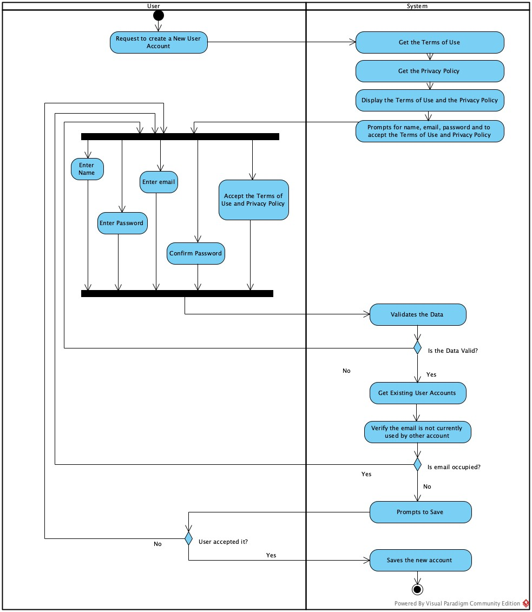

3.3.2 AD02 – Get Existing User
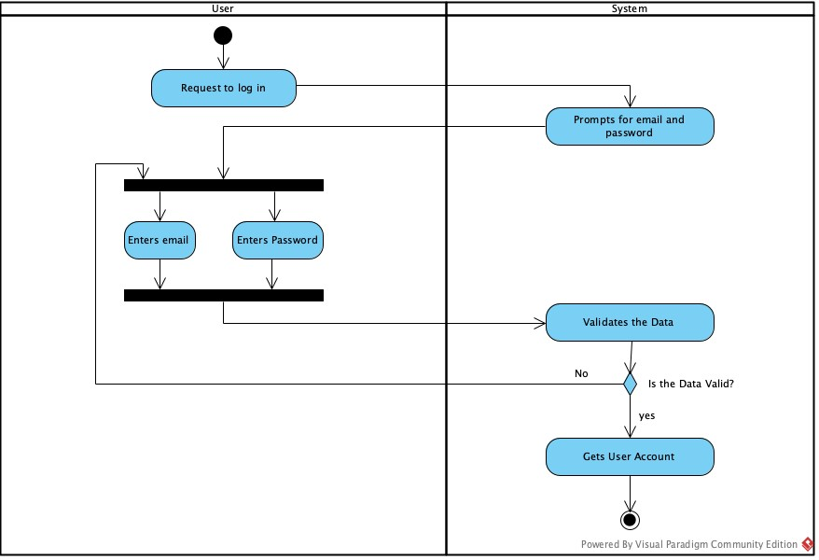

3.3.3 AD03 – Add a New Clothing item
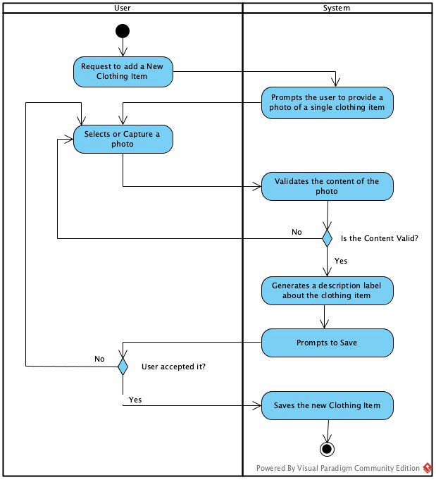

3.3.4 AD04 – Get New Outfit Recommendations
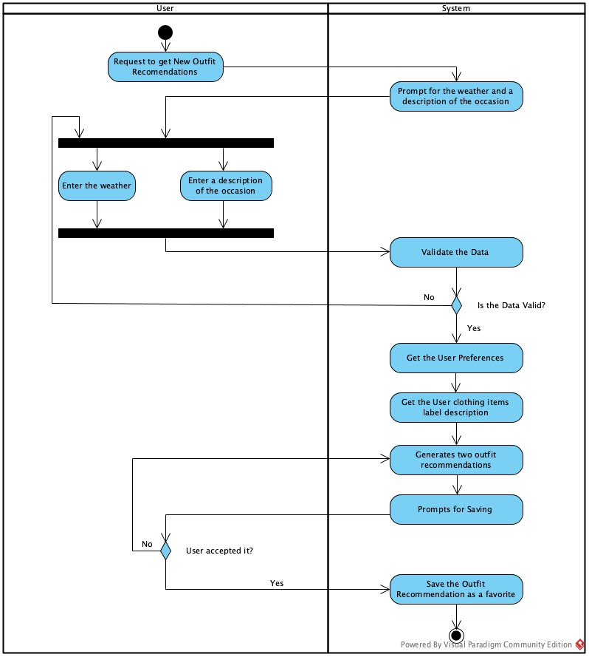

3.3.5 AD05 – Delete a Favorite Outfit Recommendation
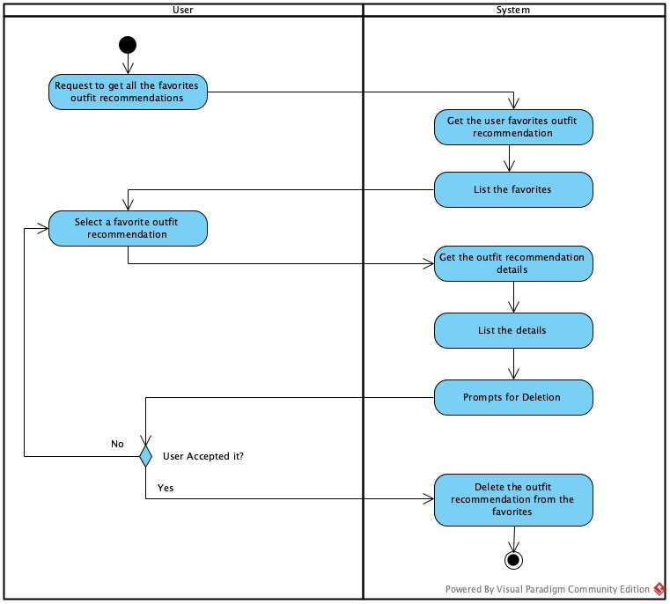

3.3.6 AD06 – Edit User Preferences
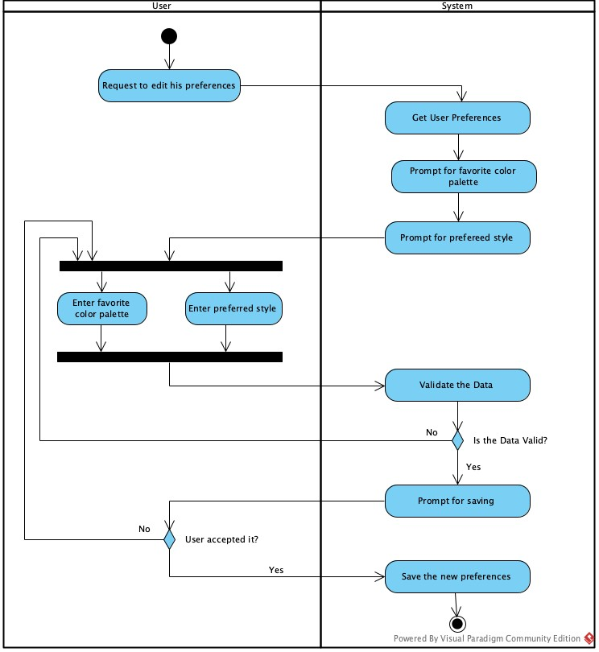

3.3.7 AD07 – Delete a Clothing Item
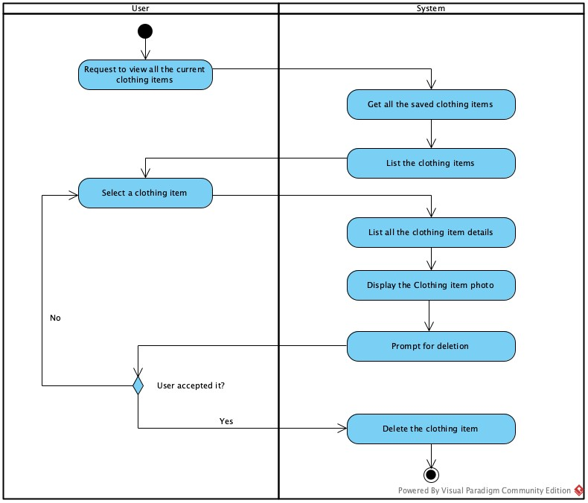

3.3.8 AD08 – Log Out
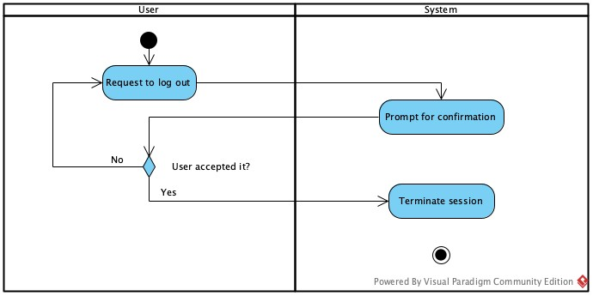

3.3.9 AD09 – Edit User Profile
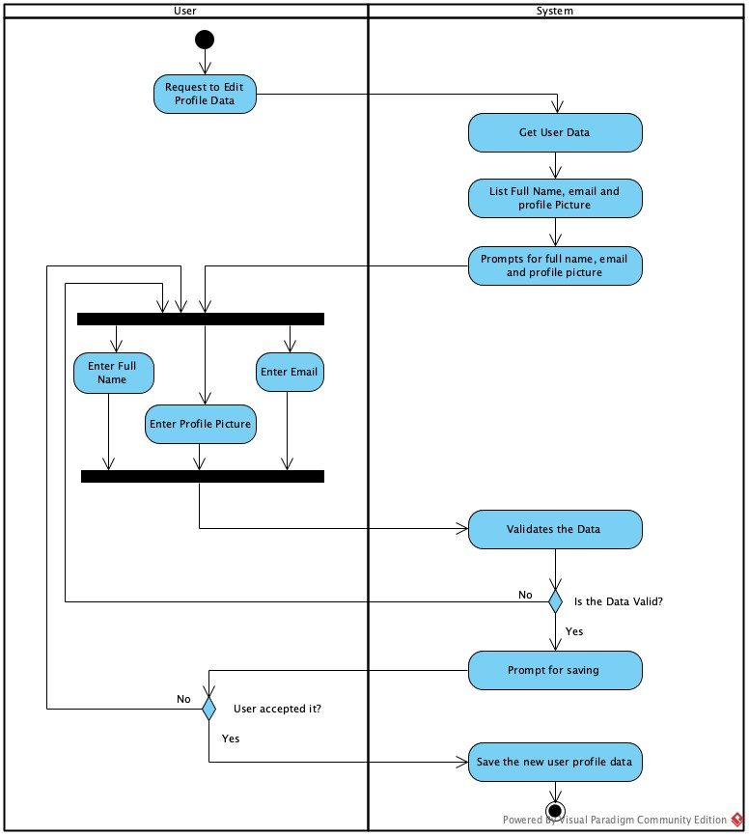

3.3.10 AD10 – View User Profile
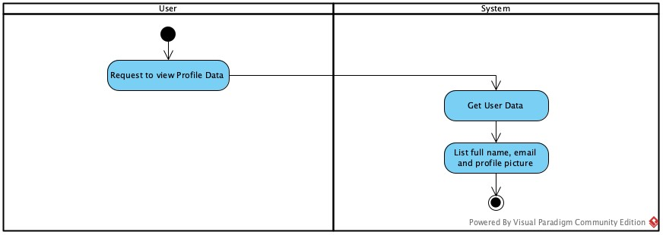

3.3.11 AD11 – View Clothing Items
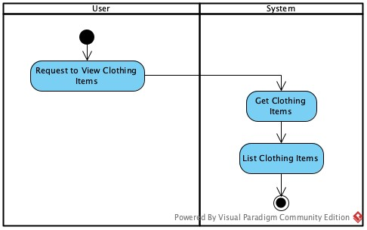

3.3.12 AD12 – View Clothing Item Details
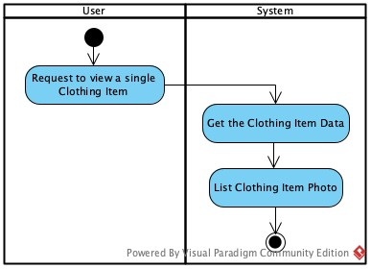

3.3.13 AD13 – View Favorite Outfit Recommendations
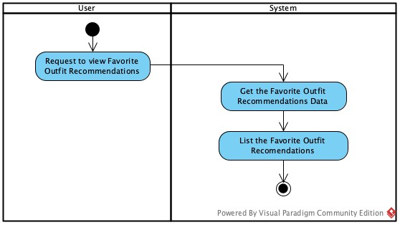

3.3.13 AD14 – View Favorite Outfit Recommendation Details
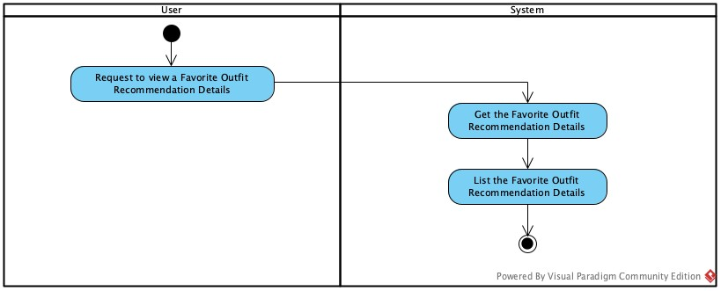

3.4 Business Rules
Business Rule # | Description | Activity Diagram | Related UCS | UI  Mock-up
BR01 | An email can be use only for one account | AD01 | UC01 | UI 2.8.1.2
BR02 | The password must have 8 characters, one uppercase letter, one number and one special character | AD01 | UC01 | UI 2.8.1.2
BR03 | User must accept the Terms of Use and Privacy Policy | AD01 | UC01 | UI 2.8.1.2
BR04 | The user must login to access the different screens on the app | AD01 | UC01 | UI 2.8.1.2
BR05 | The photo must include one individual item of clothing | AD03 | UC03 | UI 2.8.4.3
BR06 | The system must classify each clothing item into a valid clothing category. | AD03 | UC03 | UI 2.8.4.3
BR07 | A clothing item must have a generated description before it can be used in outfit recommendations. | AD03 | UC03 | UI 2.8.4.3
BR08 | Only validated clothing items can be stored in the user wardrobe. | AD03 | UC03 | UI 2.8.4.3
BR09 | Outfit recommendations must be generated only from the user’s existing wardrobe items. | AD04 | UC04 | UI 2.8.5.1 - UI 2.8.5.2
BR10 | Each outfit recommendation must contain compatible clothing categories. | AD04 | UC04 | UI 2.8.5.1 - UI 2.8.5.2
BR11 | The system must generate exactly two outfit recommendations per request. | AD04 | UC04 | UI 2.8.5.1 - UI 2.8.5.2
BR12 | Users must explicitly confirm before saving an outfit recommendation as a favorite. | AD04 | UC04 | UI 2.8.5.1 - UI 2.8.5.2
BR13 | The system allows the user to request a new pair of outfit recommendation if he didn’t save one of the current recommendations | AD04 | UC04 | UI 2.8.5.1 - UI 2.8.5.2
BR14 | Deleting a clothing item removes it from future outfit recommendations. | AD07 | UC07 | UI 2.8.4.1 - UI 2.8.4.2
BR15 | User preferences must influence the outfit generation process. | AD06 | UC06 | UI 2.8.3.2
BR16 | Contextual inputs must be provided before generating outfit recommendations. | AD04 | UC04 | UI 2.8.5.1 - UI 2.8.5.2
BR17 | User preferred color palette must be provided before generating outfit recommendations. | AD04, AD06 | UC04, UC06 | UI 2.8.5.1 - UI 2.8.5.2 - UI 2.8.3.2
BR18 | User preferred style must be provided before generating outfit recommendations. | AD04, AD06 | UC04, UC06 | UI 2.8.5.1 - UI 2.8.5.2 - UI 2.8.3.2
BR19 | Users must be able to modify their preferences at any time. | AD06 | UC06 | UI 2.8.3.2
BR20 | If the AI service is unavailable, the system must inform the user and prevent recommendation generation until the service is restored. | AD04 | UC04 | UI 2.8.5.1 - UI 2.8.5.2

Section 4 – Domain Class
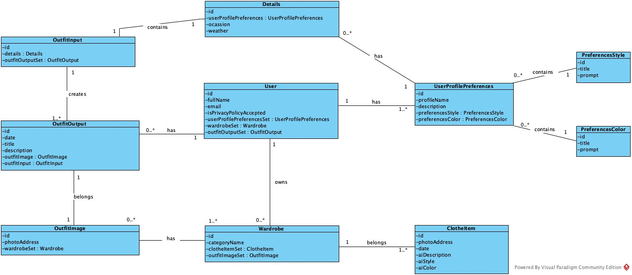

Section 5 – Database

5.1 Database Schemas

5.1.1 User Table
User Table
Field | Type | Description
id | Int | Primary Key
fullName | String | User’s full name
email | String | User’s email
isPrivacyPolicyAccepted | DateTime | Indicates whether the user has accepted the Privacy Policy.

5.1.2 Preferences Table
Preferences Style Table
Field | Type | Description
id | Int | Primary Key
title | String | Preference Style Title
prompt | String | Text prompt used as input for the AI API to generate outfit recommendations.

Preferences Color Table
Field | Type | Description
id | Int | Primary Key
title | String | Preference Color Title
prompt | String | Text prompt used as input for the AI API to generate outfit recommendations.

User Profile Preferences Table
Field | Type | Description
id | Int | Primary Key
profileName | String | Name given by the user to the profile
description | String | Description given by the user to the profile
userId | Int | Foreign Key for User Table
preferencesStyleId | Int | Foreign Key for Preferences Style Table
preferencesColorId | Int | Foreign Key for Preferences Color Table

5.1.3 Wardrobe Table
Clothing Item Table
Field | Type | Description
id | Int | Primary Key
photoPath | String | Path in memory for the photo file
createAt | DateTime | Date of creation
wardrobeId | Int | Foreign Key for Wardrobe Table
aiDescription | String | Description generated by AI
aiStyleId | Int | Foreign Key for Preferences Style Table given by AI
aiColorId | Int | Foreign Key for Preferences Color Table given by AI

Wardrobe Table
Field | Type | Description
id | Int | Primary Key
categoryName | String | Name for the clothes category
userId | Int | Foreign Key for User Table

5.1.4 Outfit Recommendation Table
Outfit Recommendation Table
Field | Type | Description
id | Int | Primary Key
createdAt | DateTime | Date of creation
occasion | String | Occasion entered by the user
weather | String | Weather condition entered by the user
userProfilePreferencesId | Int | Foreign Key for User Profile Preferences Table
recommendationText | String | Description generated by AI
isAccepted | Boolean | Indicates if the recommendation was accepted

Outfit Recommendation Item Table
Field | Type | Description
id | Int | Primary Key
outfitRecommendationId | Int | Foreign Key for Outfit Recommendation Table
clothingItemId | Int | Foreign Key for Clothing Item Table
itemOrder | Int | Order of clothing item in the outfit

5.1.5 Favourites Table

Favourite Outfit Table
Field | Type | Description
id | Int | Primary Key
createdAt | DateTime | Date of creation
userId | Int | Foreign Key for User Table
outfitRecommendationId | Int | Foreign Key for Outfit Recommendation Table
title | String | Name of the favourite outfit

5.2 Database Diagram
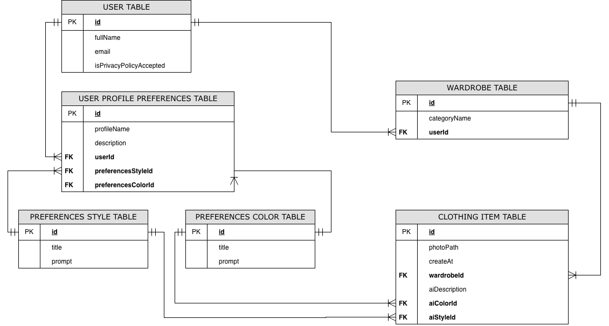
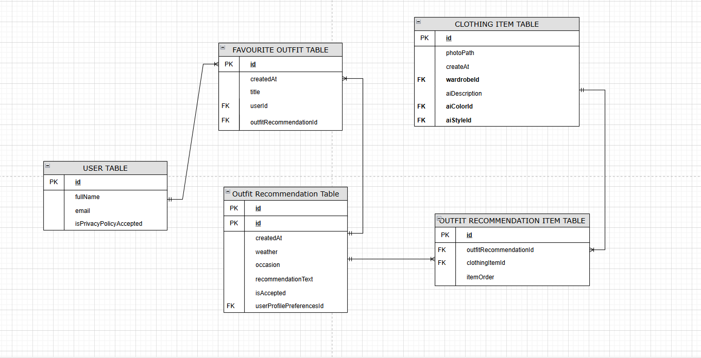

Section 6 – Product Backlog & Implementation Schedule

6.1 Product Backlog
ID | User Story | Description | Acceptance Criteria | Testing Scenarios
FR-UM-01: User Registration | As a new user, I want to create an account using my email and password so that I can access the app and receive personalized outfit recommendations. | Allows new users to register with email and password. Each account is stored in Firebase Firestore with a unique identifier for secure access and personalized recommendations. | - Users can register successfully with a valid email and password.  - Duplicate emails are rejected with an error message.  - Firebase Firestore stores a unique ID for each registered user. | - Test register with a new email → success  - Test register with an existing email → error displayed
FR-UM-02: User Login/Authentication | As a registered user, I want to log in using my email and password so that I can securely access my personalized outfit recommendations. | Allows users to authenticate with Firebase. Valid credentials grant access; invalid credentials return a clear error message. | - Valid credentials allow login.  - Invalid credentials return a meaningful error message.  - Logged-in users are directed to the main app screen. | - Test Login with correct credentials  - Test Login with incorrect password
FR-UM-03: Maintain authenticated session | As a user, I want to remain logged in so that I don’t have to log in repeatedly. | This feature maintains an active authenticated session for the user during app usage, allowing continuous access to features without repeated authentication. | - User remains logged in after successful authentication  - Session persists while app is active  - Session expires after logout or timeout  - User is redirected to login if session is invalid | - Test session persistence after login  - Test session expiration  - Test app reopen with active session
FR-UM-04: Logout functionality | As a user, I want to log out so that I can securely exit my account. | Allows users to terminate their session and prevent unauthorized access to their account. | - User can trigger logout action  - Session is terminated immediately  - User is redirected to login screen  - Protected screens are no longer accessible | - Test successful logout  - Test access after logout  - Test session invalidation
FR-UM-06: Prevent unauthorized access | As a user, I want my data to be secure so that other users cannot access it. | Ensures that users can only access their own data and prevents unauthorized access to other users’ information. | - Users can only access their own data  - Unauthorized access is blocked  - Secure authentication is enforced  - Data is isolated per user | - Test access to another user’s data  - Test unauthorized access attempt  - Test secure data retrieval
FR-AI-01: Analyze Contextual Inputs Using AI | As a user, I want the system to analyze my inputs such as preferences, occasion, and season so that the AI can provide relevant outfit recommendations. | The AI service processes user inputs to understand the user’s context, ensuring outfit recommendations are relevant and tailored. | - Contextual inputs are collected and sent to AI.  - AI returns processed data ready for recommendation generation. | - Test Input preferences, occasion, season → verify AI processes correctly
FR-AI-02: Combine AI Output with Rule-Based Logic | As a user, I want AI-generated outfit suggestions to follow style rules so that the recommendations are consistent and visually appropriate. | The system applies predefined rules (e.g., color matching, formality) to AI outputs before presenting recommendations. | - AI suggestions comply with all predefined rules.  - Invalid combinations are corrected automatically. | - Test Input that would break rules → verify output follows rules
FR-AI-03: Generate 2 Outfit Recommendations | As a user, I want the system to generate two outfit options so that I can choose the one I like best. | The system generates and displays two outfit recommendations based on AI analysis and rules. | - Two outfit options are displayed per request.  - Both outfits are valid and visually appropriate. | - Test Scenario 1 – Request recommendations → 2 valid outfits appear
FR-AI-04: Accept one of the generated outfit recommendations | As a user, I want to select one outfit recommendation so that I can use or save it. | Allows users to accept one of the generated outfit recommendations as their preferred option. | - Two outfit options are displayed  - User can select one outfit  - Selected outfit is marked as accepted  - User can proceed to save it | - Test selecting an outfit  - Test saving selected outfit  - Test selection UI interaction
FR-AI-05: Request a new set of outfit recommendations | As a user, I want to generate new outfit options so that I can explore alternatives. | Allows users to request a new set of outfit recommendations without restarting the process. | - User can request regeneration  - System generates two new outfits  - Previous results are replaced  - No app restart required | - Test regenerate action  - Test new results generation  - Test multiple regenerations
FR-LS-01: Store User Preferences Locally (SQLite) | As a user, I want my preferences to be saved locally so that the app can remember them even when offline or after closing. | The system stores user preferences in SQLite, allowing faster access and offline support. | - Preferences persist across app restarts.  - Preferences can be read back to pre-fill AI inputs or settings. | - Test Save preferences → close app → reopen → preferences are intact
FR-LS-02: Store favorite outfit recommendations locally | As a user, I want to save outfit recommendations so that I can access them later. | Stores selected outfit recommendations locally on the device for future access. | - User can save an outfit  - Outfit is stored locally  - Saved outfits persist after restart  - User can retrieve saved outfits | - Test saving outfit  - Test retrieving saved outfit  - Test persistence after restart
FR-LS-05: Isolate local data per authenticated user | As a user, I want my data to be separated so that my information remains private. | Ensures that local data storage is isolated per authenticated user on the device. | - Data is stored per user session  - Users cannot access other users’ data  - Switching users changes dataset  - No data leakage occurs | - Test multi-user scenario  - Test data isolation  - Test switching accounts
FR-LS-06: Store AI-generated categories and descriptions locally | As a system, I want to store AI-generated clothing data so that it can be reused. | Stores AI-generated clothing categories and descriptions locally to avoid repeated processing. | - AI outputs are stored locally  - Data persists across sessions  - Data is retrievable  - No need to reprocess images | - Test storage of AI data  - Test retrieval  - Test persistence
FR-IC-01: Capture clothing photos via camera | As a user, I want to capture a clothing photo so that I can quickly add it to my wardrobe. | Allows users to capture images using the device camera for clothing item input. | - Camera opens successfully  - User can capture image  - Image is stored temporarily  - User can proceed with upload | - Test camera access  - Test image capture  - Test cancel capture
FR-IC-02: Upload existing clothing photos | As a user, I want to upload a photo from my gallery so that I can use existing images. | Allows users to select and upload clothing images from their device storage. | - Gallery opens successfully  - User can select image  - Selected image is loaded  - User proceeds to validation | - Test gallery selection  - Test invalid file  - Test cancel upload
FR-IC-03: Submit uploaded images to AI service for validation | As a system, I want to validate images so that only valid clothing items are processed. | Sends uploaded images to the AI service for validation before further processing. | - Image is sent to AI  - AI returns validation result  - Invalid images are rejected  - User receives feedback | - Test valid image  - Test invalid image  - Test error response
FR-IC-06: Submit validated images for AI semantic analysis | As a system, I want to analyze validated images so that clothing data can be generated. | Processes validated images using AI to prepare them for category and description generation. | - Valid image is processed  - AI confirms readiness  - Data is passed to analysis step | - Test valid image processing  - Test AI response  - Test processing failure
FR-AI-07: Analyze validated clothing images for category | As a system, I want to classify clothing items so that they can be used in outfit generation. | Determines the category of each clothing item using AI analysis. | - Category is generated  - Category matches predefined list  - Category is stored | - Test correct classification  - Test unknown item  - Test classification error
FR-AI-08: Generate textual description for each validated image | As a system, I want to describe clothing items so that they can be used as input for recommendations. | Generates a textual description of each clothing item based on its visual features. | - Description is generated  - Description is concise  - Description is stored  - Description matches item | - Test description generation  - Test accuracy  - Test missing description
FR-AI-09: Use AI-generated descriptions as input for outfit generation | As a system, I want to use descriptions instead of images so that processing is optimized. | Uses AI-generated textual descriptions as the main input for outfit recommendation generation. | - Descriptions are used as input  - No reprocessing of images  - Recommendations are generated  - Performance is improved | - Test recommendation generation  - Test without image processing  - Test performance improvement
FR-LS-07: Associate stored descriptions with image references | As a system, I want to link clothing descriptions to images so that data remains consistent. | Associates each AI-generated description with its corresponding image reference. | - Each description has an image reference  - Data linkage is maintained  - Data can be retrieved together | - Test data association  - Test retrieval  - Test consistency

